LOST KEY PROGRAMMING MAY REQUIRE A PASSWORD, KEY CUT CODE, CYLINDER LOCK REPLACEMENT, A SECOND KEY AND MORE. PRICES MAY VARY. ALWAYS CALL TO DOUBLE CHECK 914-648-2844. CARLOS

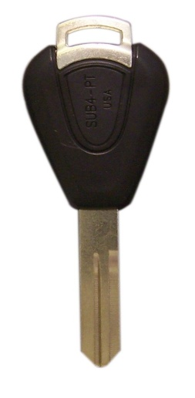
Subaru
Minimum Deposit $44 x KEY

- B9 Tribeca, 2006-2013
- Forester, 2005-2008 $120 LOST KEYS PAYS $130 Get 2x
- Impreza, 2005-2007 $190
- Legacy, 2005-2009
- Outback, 2005-2009 CUT+PROGRAMMING
- Tribeca, 2006-2013

Toyota
Minimum Deposit $74 x KEY
2014-2016 Prius (Make sure original key has an H not a G) 2013-2015 Toyota Rav4, Toyota Highlander 2014-2016

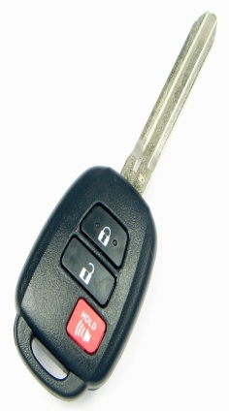
CUT+PROGRAMMING $153 Lost key pays $168
Get 2 x $260

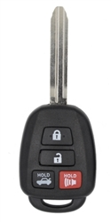
2012-16 Toyota Camry
Minimum Deposit $71 x KEY
$ 151 Lost key pays $166
Get 2 x $257
CUT+PROGRAMMING

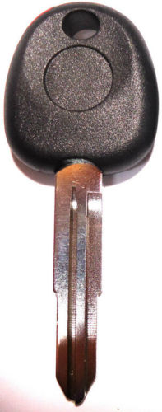

Hyundai 99-2010
Minimum Deposit $34 x KEY
$113 Lost key pays $123
Get 2 x $180
CUT+PROGRAMMING

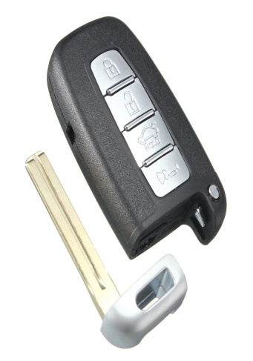
HYUNDAI / KIA 2009-2016
Minimum Deposit $94 x KEY
L.Cut+Programming
$176 Lost key pays $191
Get 2 x $297

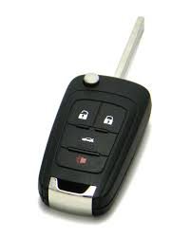
CADILLAC/ GM/CHEVY /BUICK 2016-2006
Minimum Deposit $95 x KEY
L.Cut+Programming
$183 Lost key pays $198
2 x $308

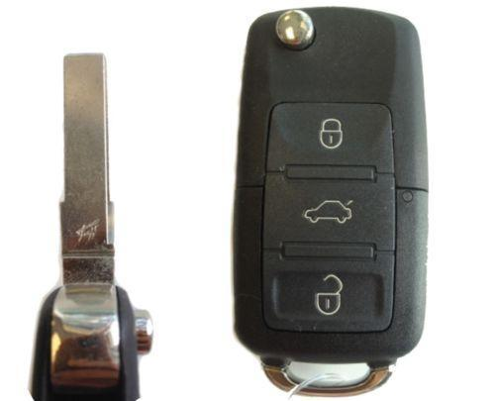
2002-2008 Volkswagen
Minimum Deposit $102 x KEY
L.Cut+Programming
$196 Lost key pays $211Get 2 x $329

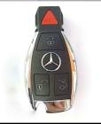
Mercedes Benz 2005-2008
Minimum Deposit $125 x KEY
$212 Lost key pays $227
L.Cut+Programming
Get 2 x $355

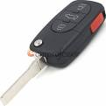
Audi A4 1997-2005
Minimum Deposit $108 x KEY
$200 Lost key pays $215
Get 2 x $335
L.Cut+Programming

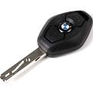
BMW 99-2008
Minimum Deposit $91 x KEY
$188 Lost key pays $203
Get 2 x $316
L.Cut+Programming

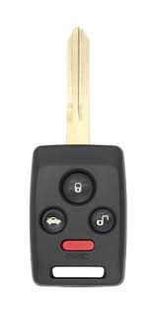
2006 2007 2008 SUBARU LEGACY OUTBACK TRIBECA
No more need for separate remote
Cut+Programming
Minimum Deposit $58 x KEY
$142 Lost key pays $157
Get 2 x $242

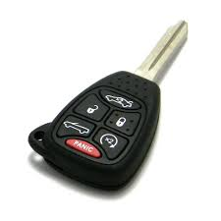
2015-2004 Jeep/Dodge/Chrysler
Minimum Deposit $48 x KEY
$141 Lost key pays $156
Get 2x$241 Cut+Programming

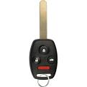
Honda 2003-2014
Minimum Deposit $87 x KEY
$170 Lost key pays $185
Get 2 x $287

2004-2013 CHEVY-GMC
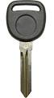
Minimum Deposit $28 x KEY
$113 Lost Key pays $123
Get 2x $180 Cut+Programming

Ford VAN/Truck 08-13 E 150 250 350 450 550
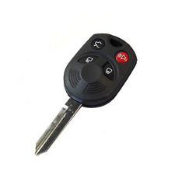
No more need for
separate key and remote
Minimum Deposit $53 x KEY
$145 Lost key pays $160
Get 2 x $247

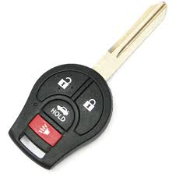
NISSAN Minimum Deposit $37 x KEY
$126 Lost key pays $141
2003-2009 350Z Get 2 x $217
2004-2009 Quest
2007-2016 Sentra Programming+Cut

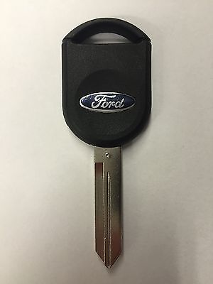
FORD 99-2014 KEY Minimum Deposit $44 x KEY
$124 Lost Key Pays $134

Get 2 x $196
Programming+Cut

2016-2000 FORD/LINCOLN/MAZDA/MERCURY
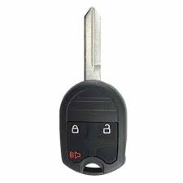
Call for compatibility
Minimum Deposit $56 x KEY
$147 Lost key Pays $162

Get 2x $250 No more need for separate remote unit Programming+Cut

